**Functions Part 3 Outputs and Return Values**

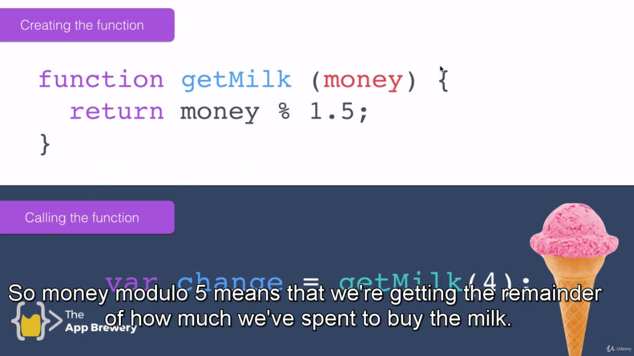

Return change/remaining money using modulo % function.

function getMilk(money){

console.log("Leave House");

console.log("Move Right");

console.log("Move Right");

console.log("Move Up");

console.log("Move Up");

console.log("Move Up");

console.log("Move Up");

console.log("Move Right");

console.log("Move Right");

var noOfBottles = Math.floor(money/1.5);

console.log("Buy "+noOfBottles+" bottles of Milk.");

console.log("Move Left");

console.log("Move Down");

console.log("Move Down");

console.log("Move Down");

console.log("Move Down");

console.log("Move Left");

console.log("Move Left");

console.log("Enter House");

return money%1.5;

}

//Function Call

var change = getMilk(4);

console.log("Return remaining money: "+change);

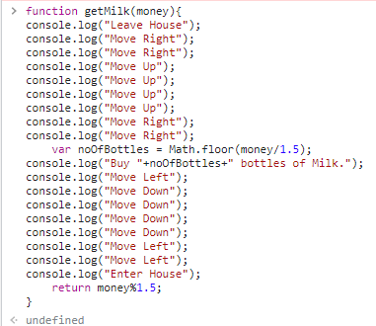

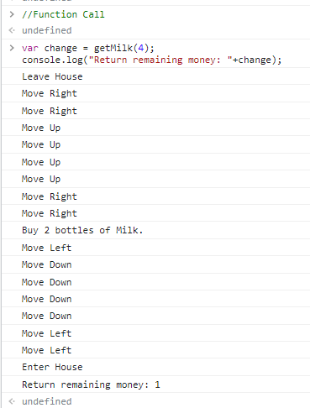

**Code 2:**

function getMilk(money){

console.log("Leave House");

console.log("Move Right");

console.log("Move Right");

console.log("Move Up");

console.log("Move Up");

console.log("Move Up");

console.log("Move Up");

console.log("Move Right");

console.log("Move Right");

console.log("Buy "+calcBottles(money,1.5)+" bottles of Milk.");

console.log("Move Left");

console.log("Move Down");

console.log("Move Down");

console.log("Move Down");

console.log("Move Down");

console.log("Move Left");

console.log("Move Left");

console.log("Enter House");

console.log("Hello master, here is your "+calcChange(money,1.5)+" change.");

}

////////

//Calculate Bottles Function

function calcBottles(startingMoney, costPerBottle){

var noOfBottles = Math.floor(startingMoney/costPerBottle);

return noOfBottles;

}

//////////

//Calculate Change Function

function calcChange(startingMoney, costPerBottle){

var change = startingMoney%costPerBottle;

return change;

}

///////////////

//Function Call

getMilk(10);

